*A Word document that includes the following*

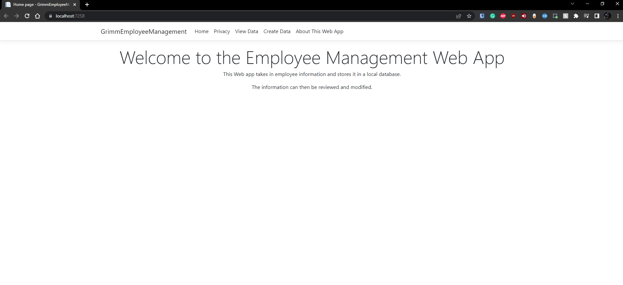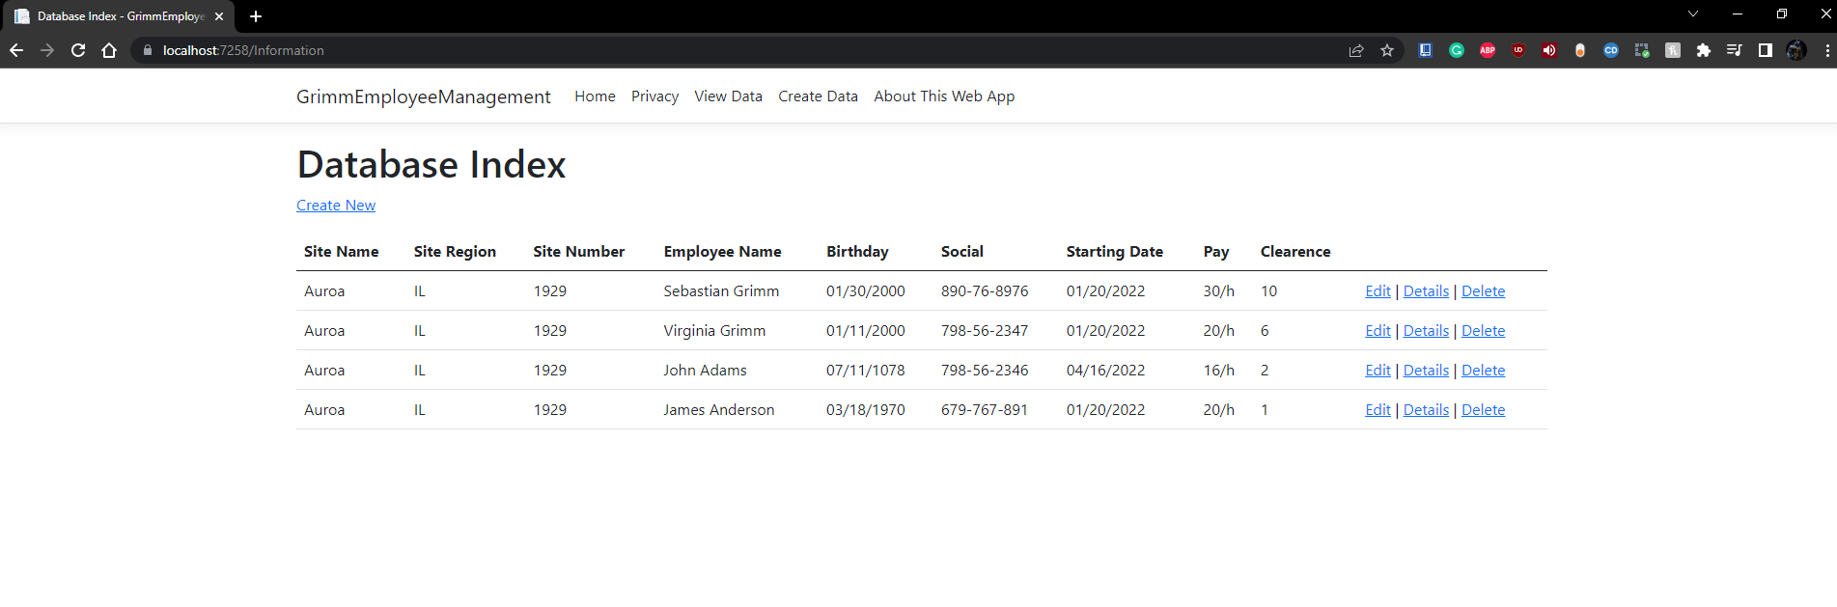*A screenshot of your webpage showing at least four pages from it. (8points)*

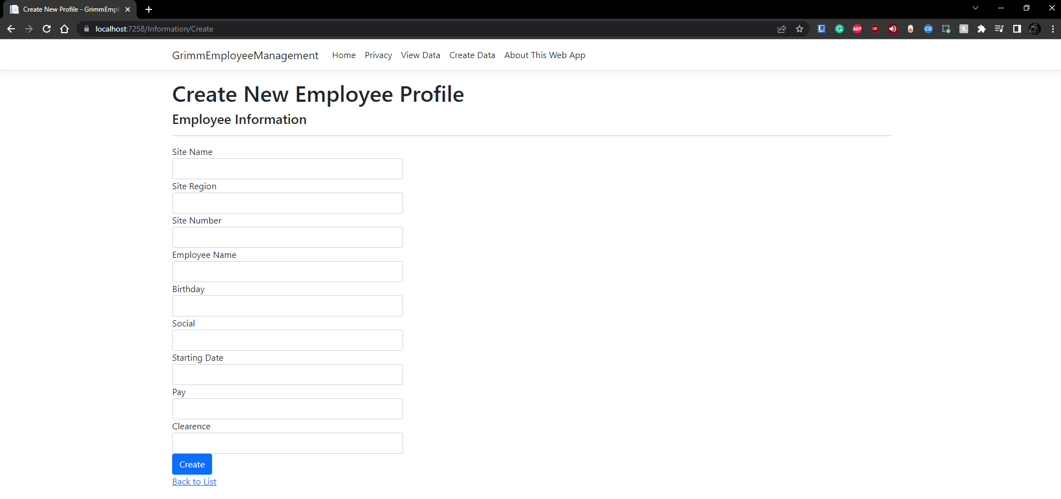

*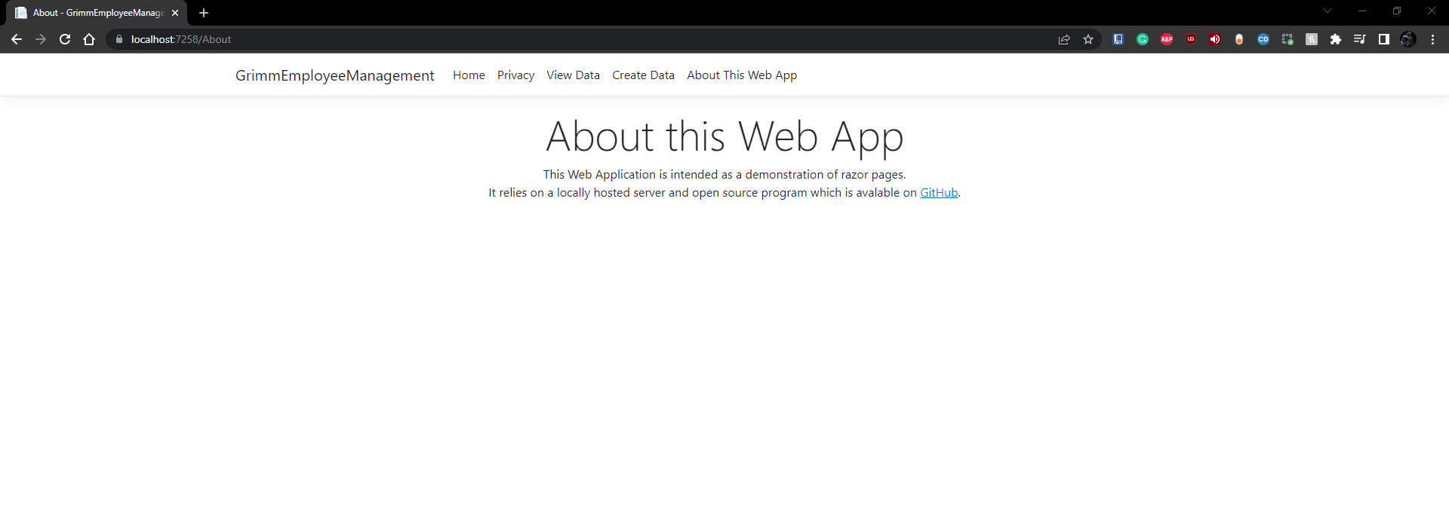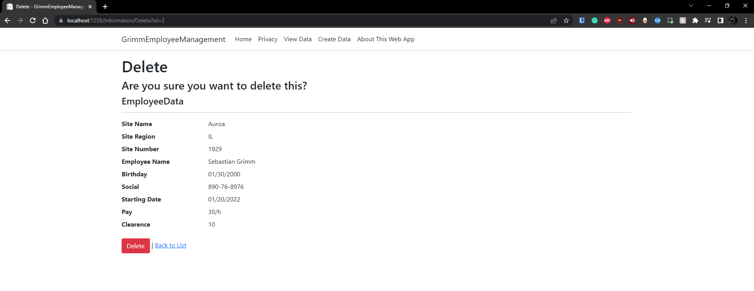*

*A screen shot of your SQL Server Object Explorer with your application's data*

*table open and showing the data inside it. (4points)*

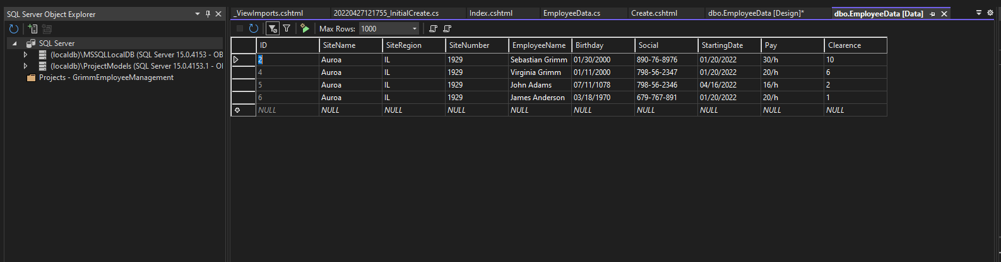

Uniform Resource Locator: https://grimmemployeemanagement20220427090728.azurewebsites.net/

Parts that dont require database.

https://grimmemployeemanagement20220427090728.azurewebsites.net/

https://grimmemployeemanagement20220427090728.azurewebsites.net/Privacy

https://grimmemployeemanagement20220427090728.azurewebsites.net/About

Parts that require database,

https://grimmemployeemanagement20220427090728.azurewebsites.net/Information

https://grimmemployeemanagement20220427090728.azurewebsites.net/Information/Create

SOME OF THIS CONTENT IS IN GERMAN (my default).

Azure was really fighting me here and it would not translate some of the windows.

A Word document that provides evidence that things are configured in Azure.

A screenshot that shows your list of app services (2 points)

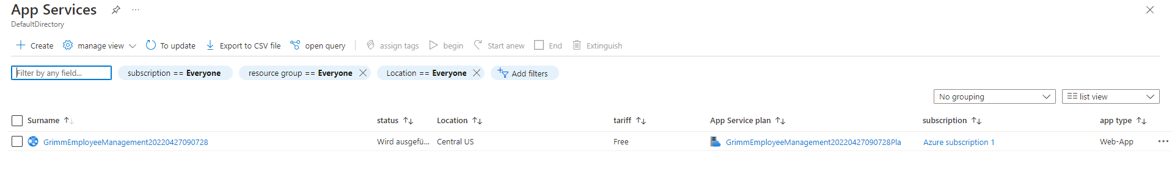

A screenshot that shows the overview page for your app service (2 points)

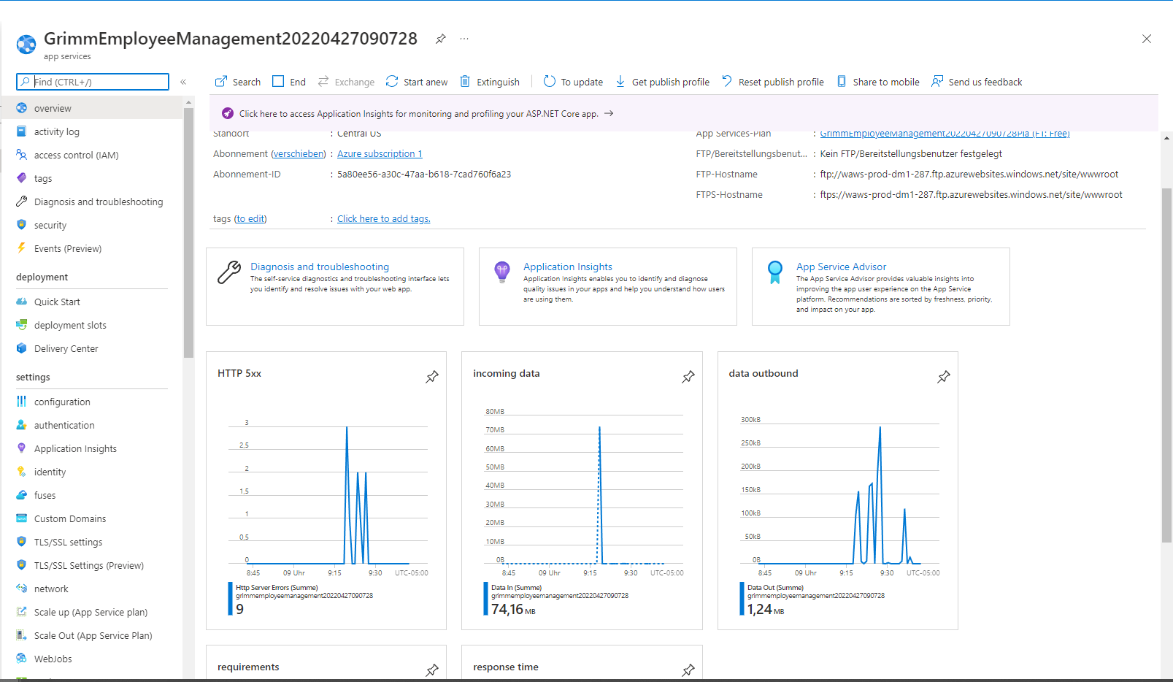

A screenshot that shows the configuration page with the setting specified that launches the application in Development mode (4 points)

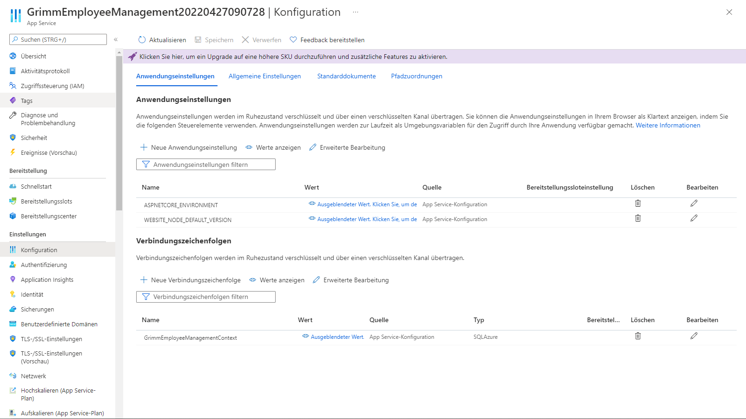

A screenshot that shows your list of databases (2 points)

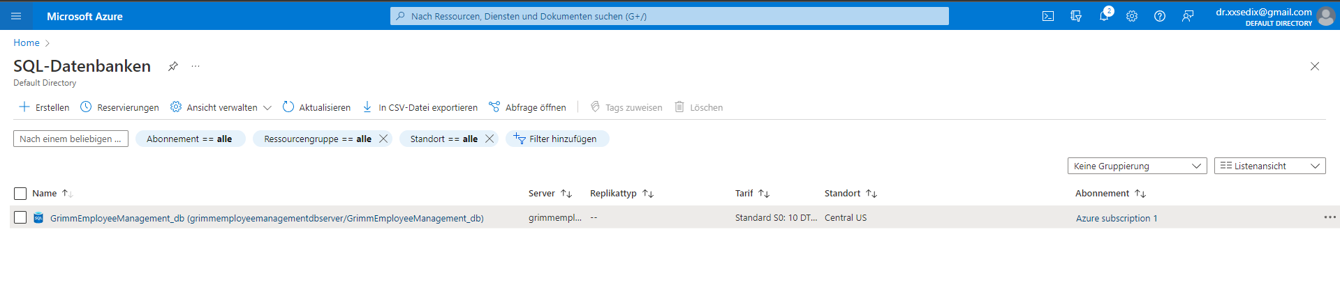

A screenshot that shows the data in the database your application uses. (4 points)

